Achiever’s List of MSM Institute of Ayurveda Alumni
Sr. No. |  | Name & address | Contact No. & Email address | Present place of working
1. | 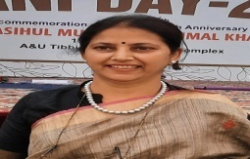 | Dr. Yogita Munjal  B-20, Naraina vihar, Newdelhi-110005 | 7838980670  dryogitamunjal@gmail.com | Deputy Director, Directorate of AYUSH, Govt. Of NCT Delhi, Tibia College Campus, Karol Bagh, New Delhi 110005
2. | 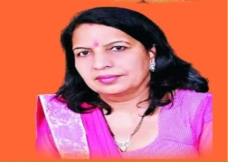 | Dr. Kiran Kalkal  Kalkal Nursing Home, Jhajjar | 9467918000  dr.kiran.kalkal@gmail.com | CEO & Founder Kalkal Nursing Home, Jhajjar, Haryana
3. | 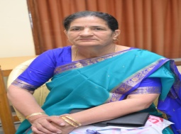 | Prof. Sarla  H.No. 143, Sector -4 Rohtak, Haryana | 9466593421  dr.sarladuhan@gmail.com | Ex. Proctor (BPSMV) Ex. Dean (Faculty of Ayurveda)  Ex.Head, Dept. of Kriya Sharir MSM Institute of Ayurveda, BPSMV, Khanpur kalan, Sonipat, Haryana
4. | 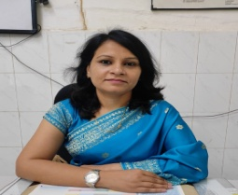 | Dr. Mamta Rani  Anant Vihar (Mirzapur Farm) Kurukshetra, Haryana | 7404553959  docmamta18@gmail.com | Assistant Professor, Dept. Of PTSR, MSM Institute of Ayurveda, BPSMV, Khanpur kalan, Sonipat, Haryana
5. | 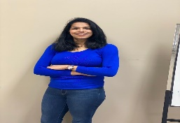 | Dr. Shweta Dewan  322 Maverick Street, N2K0A4 Waterloo, Canada | ±14166194905  shweta@ayushforlife.com | Founder, Ayurvedic Holisitic wellness Centre Practicing Ayurveda in Canada as own website www.ayushforlife.com
6. | 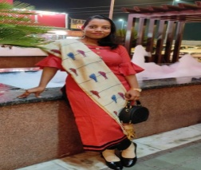 | Dr. Hemlata  H.No. 687, Saini Mohalla, Nangloi, Delhi 110041 | 9354171534  s.baberwal92@gmail.com | Assistant Professor, Dept. Of Kaya Chikitsa, MSM Institute of Ayurveda, BPSMV, Khanpur kalan, Sonipat, Haryana
7. | 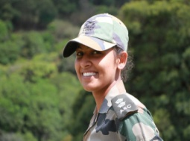 | Dr. Swati  Near Jeewandeep Hospital, Uttam Nagar, Gali No.5 Baroda Road , Gohana (Sonipat, Haryana) | 9896072579  ayurved.swati@gmail.com | Officer, Indian Army Posted at Rajauri, Jammu & Kashmir
8. | 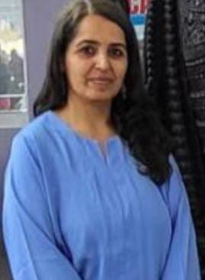 | Dr. Sangeeta Nehra  Directorate of Ayush, Sector- 3 Panchkula, Haryana | 8288050629  Sangeeta13968@gmail.com | Ex. Director AYUSH, Teaching Faculty and Incharge State Govt. Ayurvedic pharmacy, SKGAC, Ayush University, Kurukshetra, Haryana
9. | 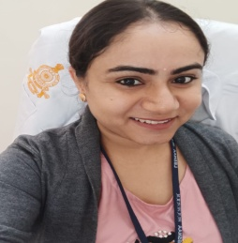 | Dr. Pooja  469, Teliwara jain chowk, Bhiwani, Haryana | 9467597918  mehtapooja561@gmail.com | Panchkarma vaidya at All India Institute of Ayurveda, New Delhi and presently working as Panchkarma Consultant LBSNAA, Mussoorie, U.K.
10. | 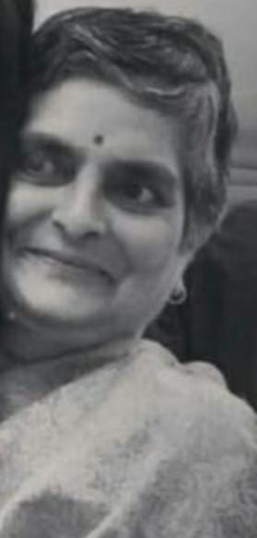 | Dr. Uma Gautam  B-26 Brahma Apartments Plot No. 7 New Delhi 75 | 9416692529  umagautam1955@gmail.com | Retired (Reader) Dept. of Dravyaguna MSM Institute of Ayurveda, BPSMV, Khanpur kalan, Sonipat, Haryana
11. | 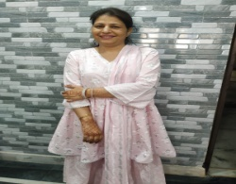 | Dr. Reena Arora  268, Ist Floor, Mukherjee Nagar, Delhi-9 | 9311279932  ayurvedicclinic2@gmail.com | Ayurvedic Practioner N-2 Mukherjee Nagar, Delhi-9
12. | 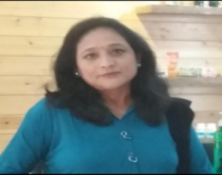 | Dr. Shashi Gupta  Amulya Herbs Pvt. Ltd. SCO-3, AmulyaTowers, Dhakoli, Zirakpur, Punjab | 9050703759  shashigupta7936@gmail.com | HOD, Ayusham ,Amulya Herbs Pvt. Ltd. SCO-3, AmulyaTowers, Dhakoli, Zirakpur, Punjab
13. | 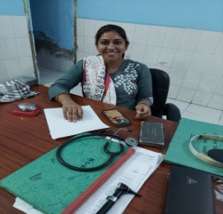 | Dr. Priti  Vill. Bigopur, PO. Dholera Dist. Mahendergarh, Haryana | 9350315858  891yadavpriti@gmail.com | Ayurvedic Pharmacist, Babakheta nath Govt. Ayurvedic college, Narnaul, Haryana
14. | 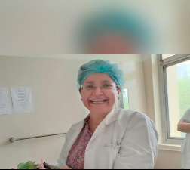 | Dr. Ritu Sethi  Holy Family Hospital, Okhla Road, New Delhi 110025 | 9891210847  drritusethi@rediffmail.com | Senior Consultant & HOD, Holy Family Hospital, Okhla Road, New Delhi 110025
15. | 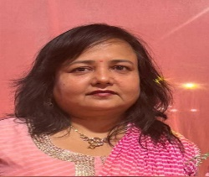 | Dr. Seema Jain  10-A Vivek Vihar, Ambala City, Haryana | 9357375499  drseemaj15@gmail.com | A.M.O.Govt. Ayurveda Dispensary, Rajpura, Distt. Patiala, Punjab
16. | 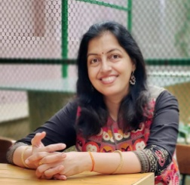 | Dr. Seema Ahlawat  C-18, C3 Housing Block, Residential complex, CBPACS, Khera Dabur, Najafgarh, New Delhi | 9999704451  Sarohaseema123@gmail.com | Working as Panchkarma Vaidya at Ch. Brahm Prakash Charak Ayurved Sansthan, Khera Dabur, Najafgarh, New Delhi
17. | 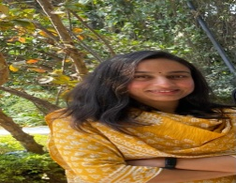 | Dr. Preeti Bhosle  M-23, Kirti Nagar, New Delhi- 110015 | 9212233999  doctopreetibhosle@gmail.com | Research Fellow, AIIMS, Delhi and Founder & Ideator Pratha Ayurveda, New Delhi
18. | 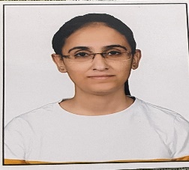 | Dr. Diksha Vashist  548/4, Railway Road, Gharaunda (Karnal) -132114 | 9468011075  dikshavashist04@gmail.com | Community Health Officer in HWC Jamalpur (Gharaunda) Haryana

