Name | Dr. Naresh Kumar | 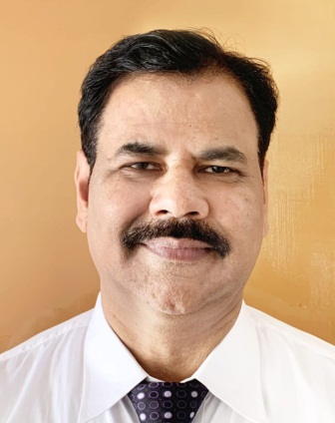
Qualification | BAMS, MD Dravyaguna Vigyan
Designation | Associate Professor & H.O.D. Department of Dravyaguna Vigyan
Registration No.  Name of Board | 20178, Council of Indian Medicine, Panchkula, Haryana
Date and place of Birth | 01/07/1972 Tarn Taran, Punjab
Total Teaching Experience | 23 Years+
Phone No. | 9416051032
Email | nareshbhargav73@gmail.com
Address | M.S.M. Institute of Ayurveda  B.P.S. Mahila Vishwavidyalaya, Khanpur Kalan, Sonipat, Haryana, India  Pin Code - 131305

